`

Fujitsu’s GDC Spec.

Date : 2006/4/25

참고자료 : FujitsuGDCs.pdf

- Overview
    - six layers
    - maximum resolution : 1280x768
    - double buffer : one for the drawing frame and the other for the display frame
    - 2D graphic engine : line and polygon drawing, shading, texture mapping, anti-aliasing, primitives, polygon fill, hardware cursor, etc
    - 3D graphic engine
    - Geometry engine
    - Overlay layers with alpha blending and alpha-plane
    - dual display – for seat-back entertainment
    - video capture
    - multimedia engine : fogging, lighting
    - analog/digital RGB video output

    - Lime : only 2D graphic engine
    - Coral-PA : include Lime and add 2D/3D graphic engine, geometry engine
    - Carmine : include Coral-PA and add multimedia engine

- video overlay
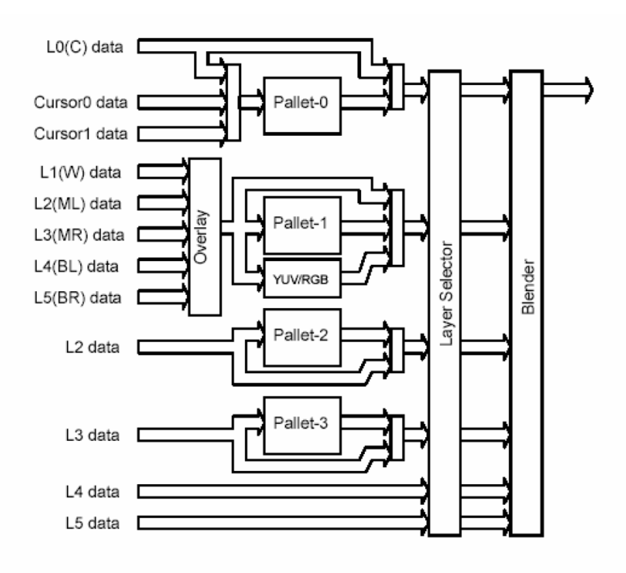

    - pallet : 256 color to RGB
    - layer selector : reordering
    - blender : alpha blending
    - four color pallets or Color Look Up Tables

- Color Type
    - 8bit/pixel
    - 16bit/pixel
    - 24bit/pixel
    - YCbCr
- Hardware cursor
    - 2 hardware cursor
    - Size : 64x64
    - Not alpha blending
- display clock
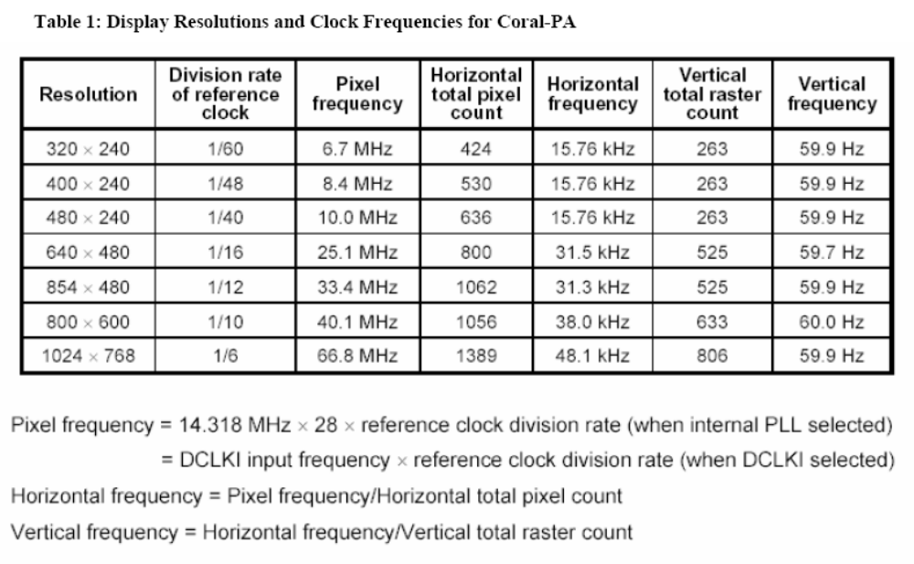
- Dual screen
  - Layer selection
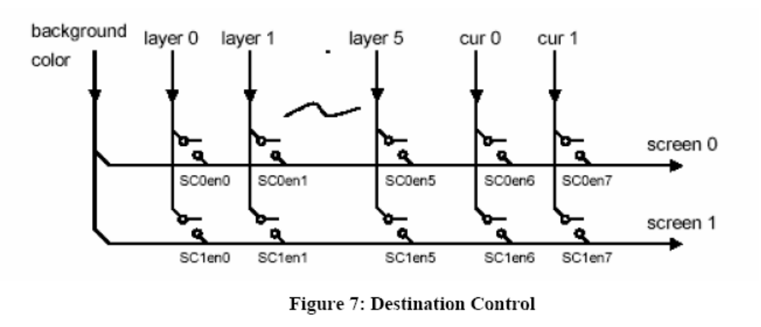
  - Mode
    - Parallel mode : one is the digital, the other is the analog.
    - Multiplex mode : need external spliter
      - digital : both(time slice)
      - analog : screen 1

